Game Plan

**Core concept:** To fit the theme “Start from nothing” the playable character will be very weak to begin with and progressively become stronger through equipments etc.

**Game Mechanism**: Rougelike, meaning each time the player play it will be different. The items, maps, enemies will be randomised. And everytime a new run begin the playable character will start fresh with default equipments.

Here’s a concept of what the maps will look like

**Setting:** I have two ideas in mind, one can be the fantasy type where the villain or monster seeks to destroy the world and the hero(player) will try to defeat it and restore peace. Or an zombie apocalypse where each run the player will just go out and seek for resources for the shelter.

**Playable Character:**

1. For the fantasy we can have different class for the player to choose that suits the theme for example: Warrior / Mage / Archer, the class will be selected before each new run and the weapon generated in the map will be specific for that class. The character will become stronger by: Finding better weapon / Finding better spells (Yes they can do spells since its fantasy) / Find unique artefacts ( Limited use item that’s really powerful, ask me in detail for some ideas)

**Core Drive:**This is something that will make the player keep wanting to play a new run after either defeat or complete the run

1. Fantasy: When the previous hero dies, it’s remaining power will be stored and help the next hero to defeat the enemy. We can use a stat tree system where everytime you finish a run you gain some exp towards this tree and when you have enough you will permanently increase your stats making the next run easier

**Map:**

I’m looking to have 4 sets for map which covers different biome (Desert , jungle, grassland etc) this applies to both scenario.

Therefore the player needs to progress through each of them to face the final boss.   
Within each biomes it will have different “rooms” some are treasure – give you upgrades / some are combat / some are mystery (like a shop or something)

Use the following diagram as a reference:

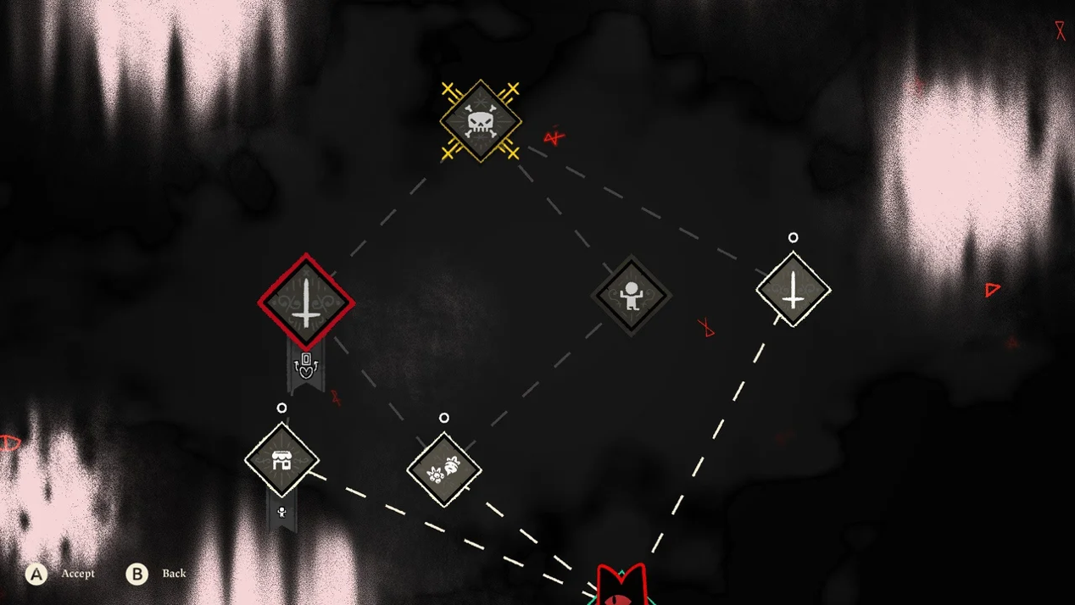

**Art style:**I’m looking to use More cartoon pixel aish art style like follow

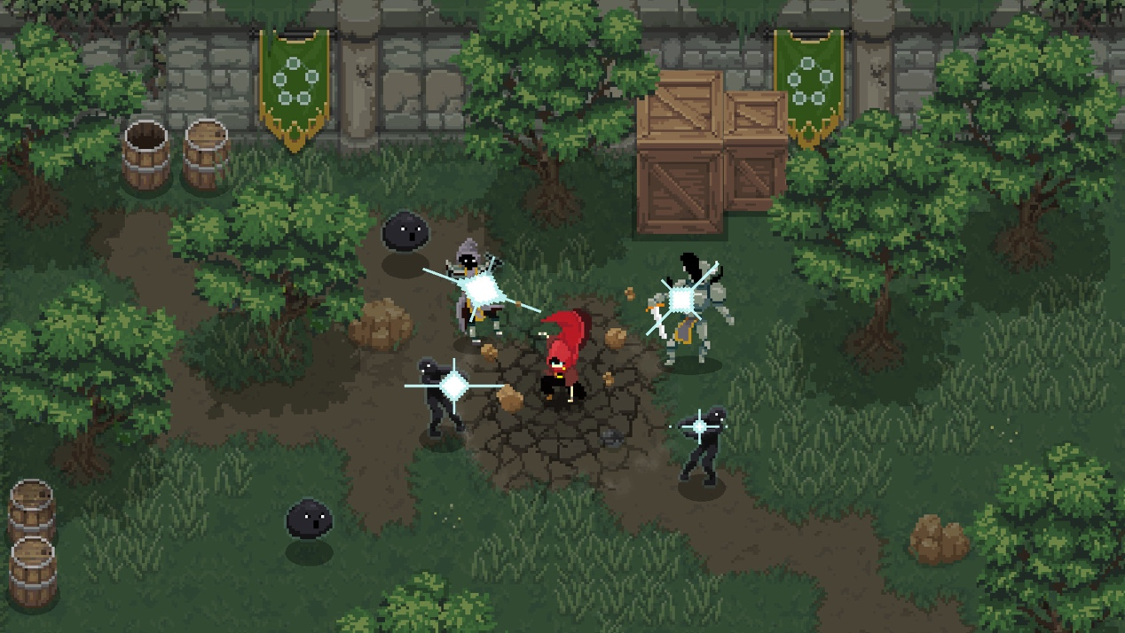

Wishing the Camera angel can be set like this because this will reduce bugs and cut our work time short on unnecessary stuff. We only need to build the rooms and that’s it. Don’t have to worry about background image etc